1. Download Link: <https://autoitscript.com/site/autoit-script-editor/downloads/>
2. Select the 64 bit version of the windows
3. Right click on “SciTE4AutoIt3.exe” and click on “Run as administrator “

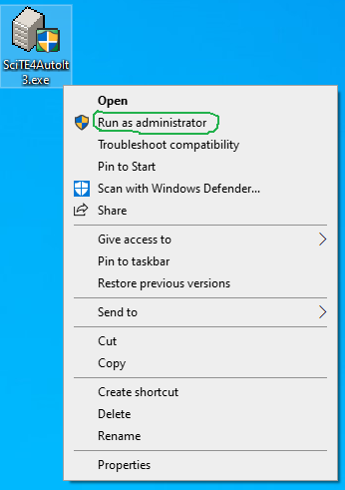

1. Click on yes

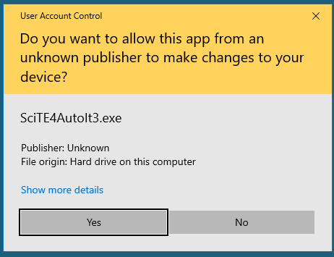

1. Click Next

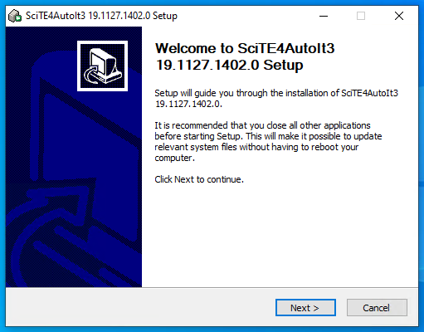

1. Click on I agree

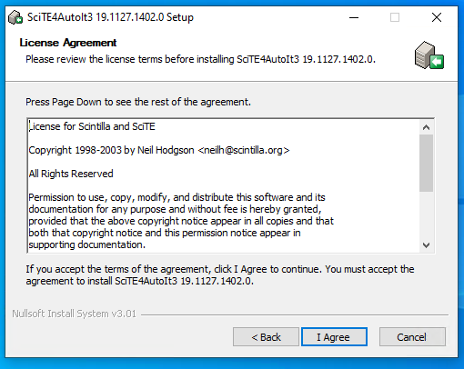

1. Wait for the process to complete

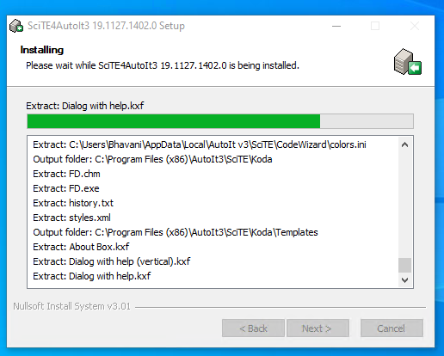

1. Click on Finish

